Tucker DeVries 2021-22 Season Analysis (Against D1 Teams only)

**Win vs Loss Statistics:**

* 23-11 with Tucker
* 29.6 MPG in Wins, 30.9 in Losses
* 44% FG% in Wins, 38% in Losses
* 53% 2P% in Wins, 44% in Losses
* 33.5% 3P% in Wins, 35% in Losses
* 11.8 FG attempts in Wins, 11.2 FG attempts in Losses
* 3.1 FTA in Wins, 2.3 in Losses
* 6.0 2PA in Wins, 4.7 in Losses
  + 19-6 when attempting 5+ 2P
* 5.8 3PA in Wins, 6.5 in Losses
* 4.6 RPG in Wins, 4.7 in Losses
* **2.5 APG in Wins, 1.3 in Losses**
  + **10-1 when he had 3+ assists**
* 1.1 SPG in Wins, 0.7 in Losses
  + 8-3 when he had 2+ steals
* 0.57 BPG in Wins, 1.27 in Losses
* 1.6 TOV in Wins, 0.9 in Losses
* 2.4 PF in Wins, 3.4 in Losses
* 14.5 PPG in Wins, 13.1 in Losses
  + 4-1 when he scored 20+
  + 3-3 when he scored less than 10
* Conclusion: we won games when Roman was being used less on the offensive end. He attempted more field goals and free throws, took more threes, and played more minutes in

games that we lost

Random Forest Results:   
This type of model runs through our schedule 1000 times and predicts, given the statistics of the game log, whether we won or lost.

* Roman’s random forest was 56% accurate overall. However, the model was 61% accurate when predicting a win (meaning when the model predicted a win, we did actually win the game)
  + Following the trend of DJ’s data and the overall team data, when we won games, Roman’s play was more predictive than in losses

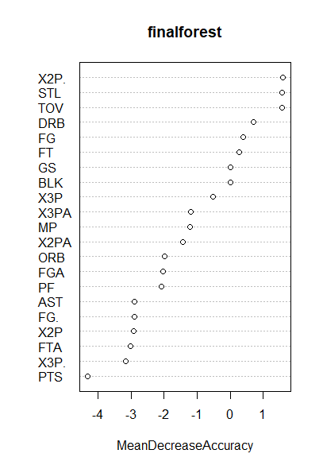

* Again, “MeanDecreaseAccuracy” values above 4 are statistically significant
* No variables were significantly significant
  + However, there is a little bit of evidence that his 2-point field goal percentage, steals, and turnovers were the most significant variables in predicting wins and losses
* What was very interesting is that “PTS” (Points Scored) is at the bottom of the list. This gives evidence towards Roman’s scoring having little effect on team success